- Accessing the NFHS Learning Center Website:
  - Visit https://nfhslearn.com/ homepage.

- View the TOP RIGHT HAND CORNER of the HOMEPAGE:
  - Already Registered with NFHS Learning Center?
  - Click:
SIGN IN
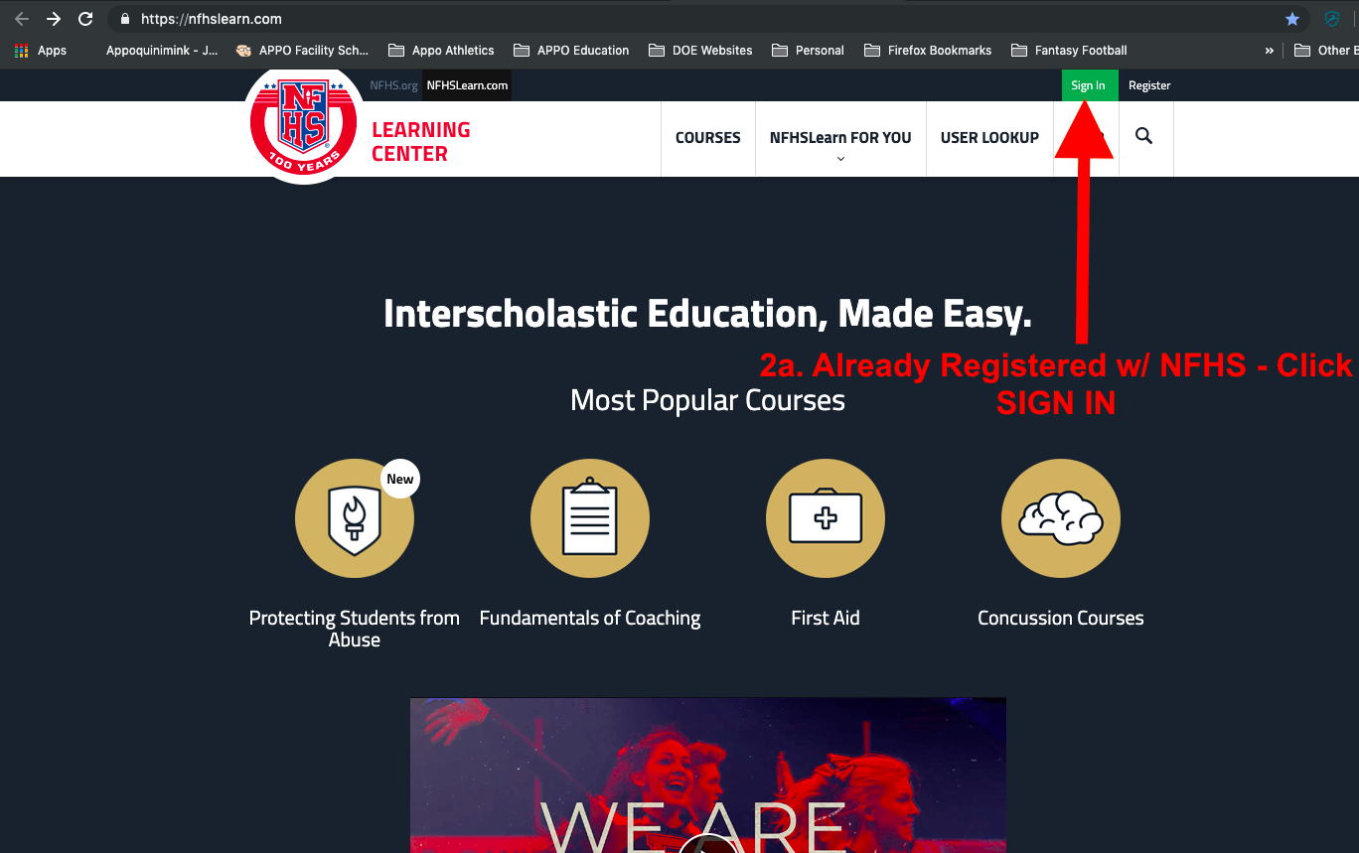
  - Not Registered and/or need to create an account?
  - Click:
Register
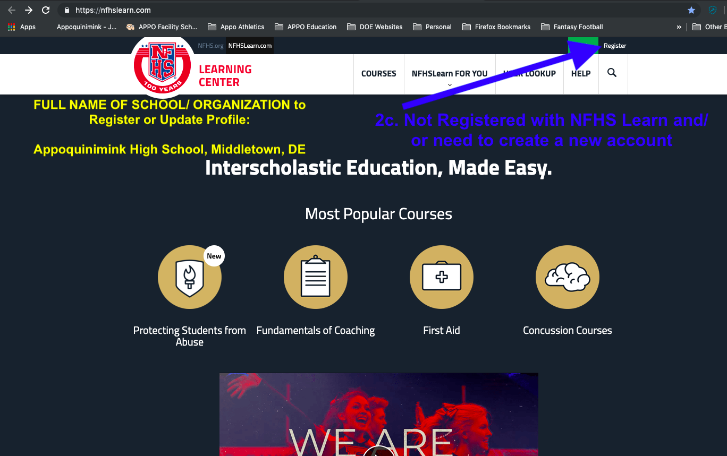

- When you are registering and/or updating your profile, enter the highlighted info below for FULL NAME OF SCHOOL/ ORGANIZATION:
  - Appoquinimink High School, Middletown, DE
  - This will help to categorize all of our staff training under one recognizable group from 2017 and on.
****UPDATED 9-1-2020****

