- Once you are logged in and have your online portal created, it should look like the screenshot below in which you can now register for free Concussion in Sports and Sudden Cardiac Awareness courses.
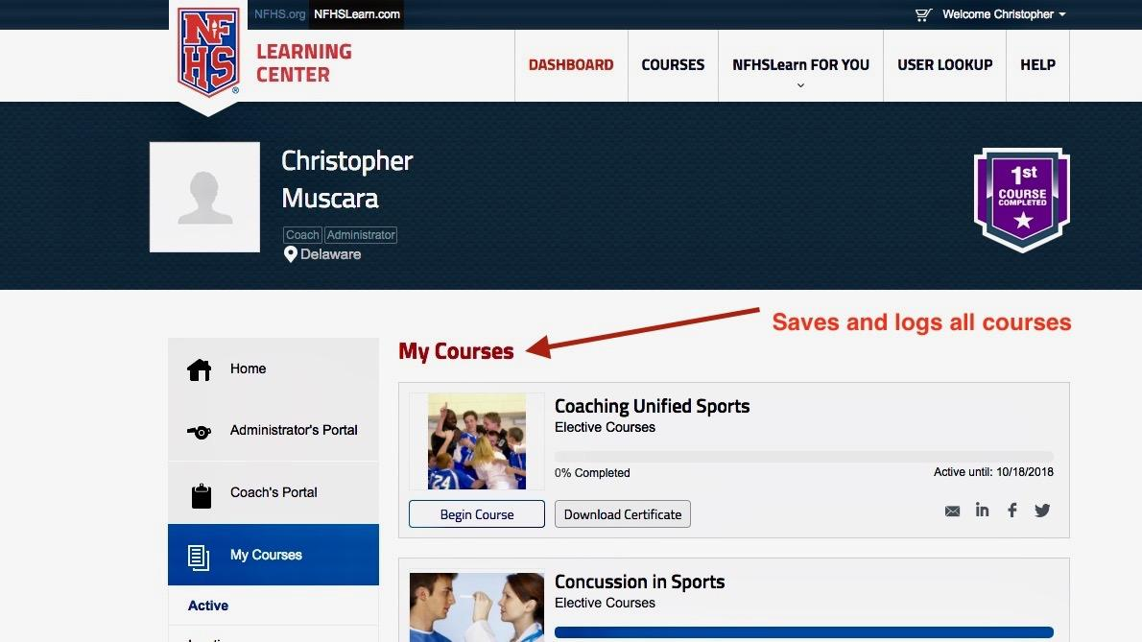
- Once you complete any courses taken via this portal, NFHS creates your own transcript so that you can view past courses taken, save, and print all certificates.

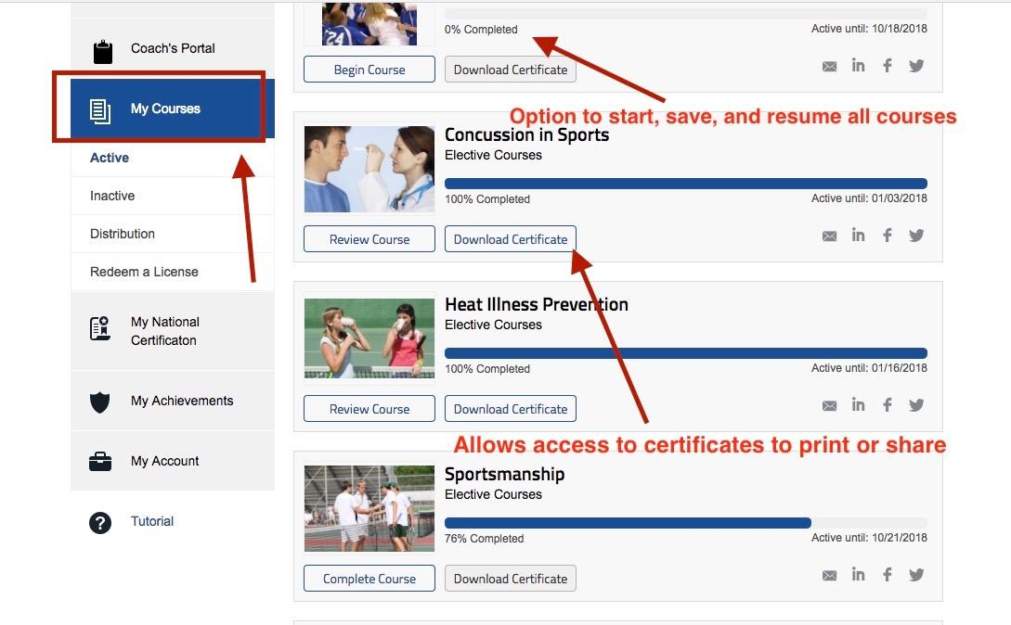
****UPDATED 9-1-2020****

