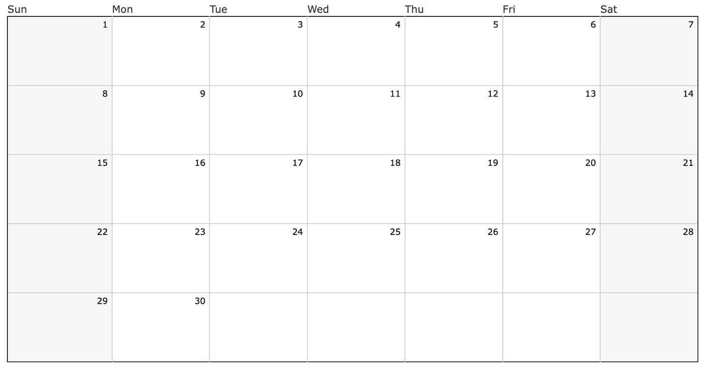
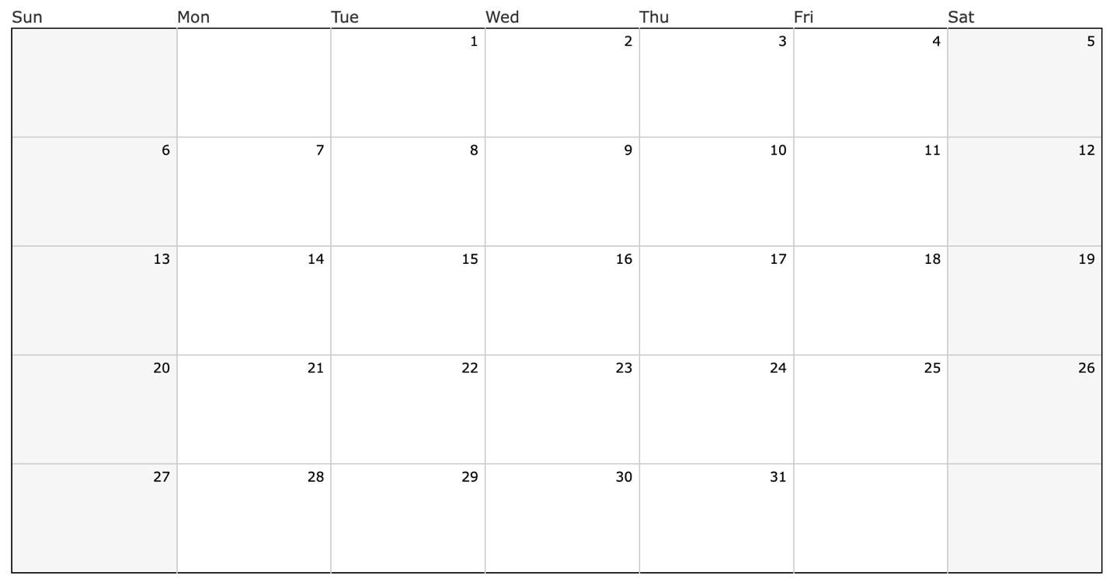
Holiday
Break
Holiday
Break
Holiday
Break
Holiday
Break
Holiday
Break
Holiday
Break
Holiday
Break
Thanksgiving
Break
Thanksgiving
Break
Thanksgiving
Break
Unified Practice
2:45-4:00
Unified Kickoff Night
4:30-7:00
Unified Practice
2:45-4:00
Unified Practice
2:45-4:00
Unified Practice
2:45-4:00
Unified Practice
2:45-4:00
Unified Practice
2:45-4:00
Try-out
Day 3- Court
2:45-4:00
Try-out
Day 2-Interveiws
2:45-4:00
Try-out
Day 1- Court
2:45-4:00
December
November
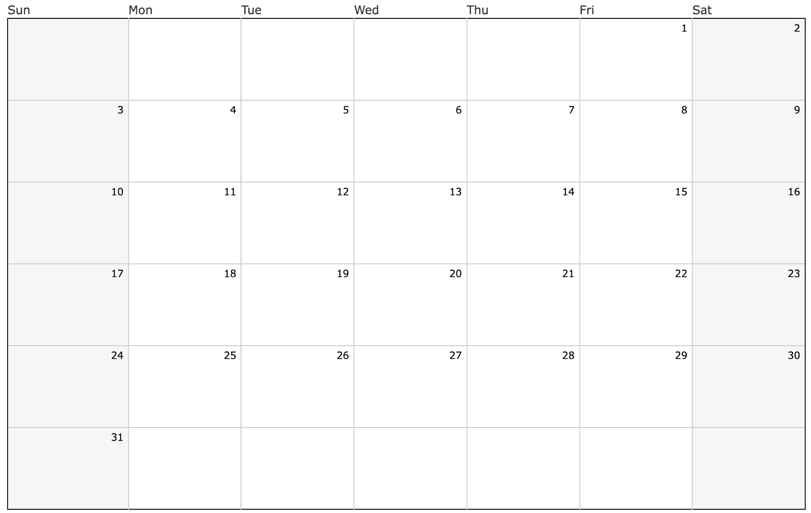
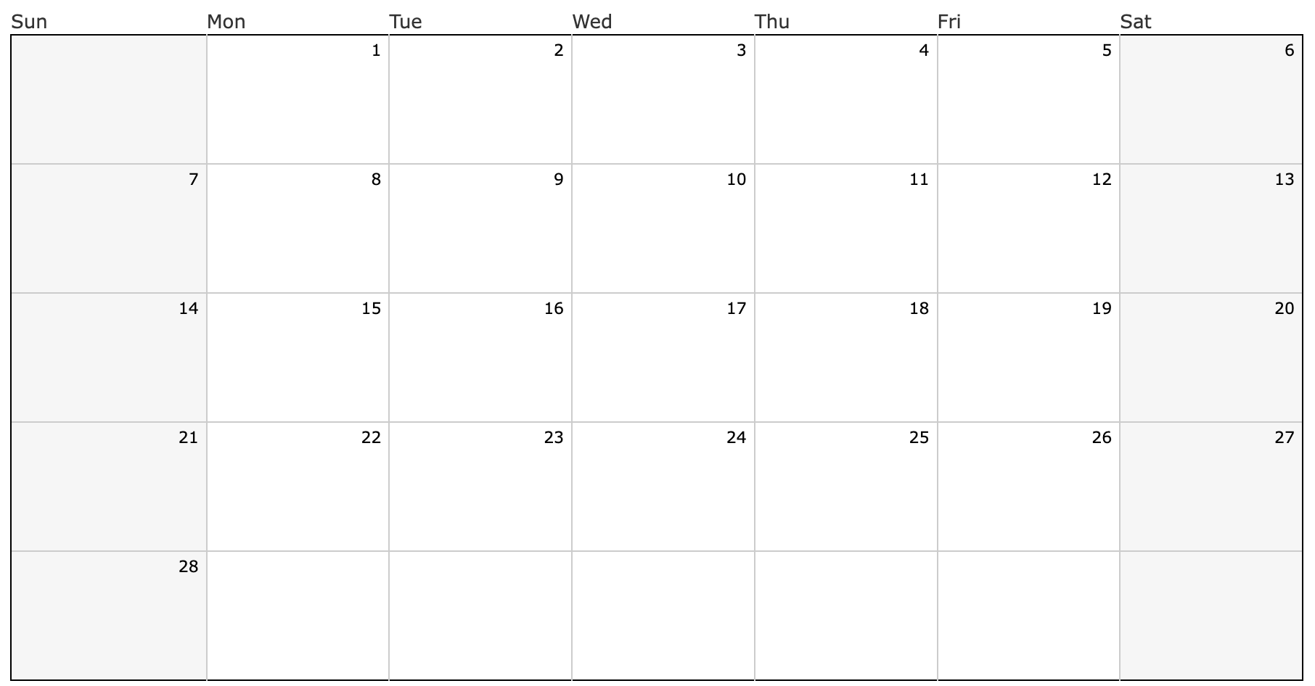
Unified Practice
2:45-4:00
Unified Practice
2:45-4:00
Unified Practice
2:45-4:00
Unified Practice
2:45-4:00
Unified Practice
2:45-4:00
Unified Practice
2:45-4:00
Unified Practice
2:45-4:00
Unified Practice
2:45-4:00
Unified Practice
2:45-4:00
Unified Game
Vs Polytech

Unified Game
Vs Lake

Unified Game
@ Milford

Unified Game
@ Dover

Unified Game
@ Polytech

Unified Game
Vs Seaford

Unified Game
Vs Milford

Unified Game
@ Lake

Unified Game
@ CR

February
January

